Guidelines FOR AUTHORS
(title of abstract 13 points, bold,
line spacing at least 15 points)
text area 16,5×24,7 cm + 1 cm for page number, page size 210×297 mm (A4),
side margins 2,25 cm, top 2,5 cm, bottom 2,5 cm, header 1,5 cm
First name SURNAME¹, First name SURNAME^{2,3} (11 points)
^{1,2,3} The name of the institution represented by the author, address
font size 9 points.
Contact: username@domainname.dom
Key words: typed in Times New Roman, 9 points, line spacing at least 11 points

Abstract:
The main body of abstract (max. 1 page) should be written in 11 point font, line spacing at least 13 points at a full length of line, i.e., 16.5 cm; each new paragraph should start with a 0.5 cm indention. It is not recommended to leave additional blank lines between paragraphs.
Mathematic formulae and tables:
Mathematic formula.
(1)
Tables.
Table 1. For table heading (9 points)
Year | 2003 | 2004 | Average
Efficacy I type | 70.00% | 80.00% | 75.00%
Error I type | 30.00% | 20.00% | 25.00%

Or figures.
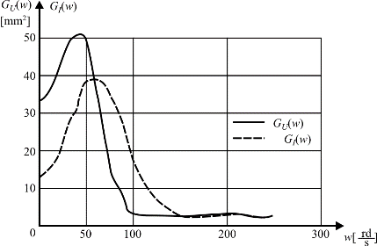
Fig. 1. For figure caption (9 points)
Acknowledgment:
The text of acknowledgments.
References (9 points)
[1] BOCEWICZ G., BANASZAK Z., WÓJCIK R., Design of admissible schedules for AGV systems with constraints: a logic-algebraic approach, In: Agent and Multi-Agent Systems: Technologies and Applications, Nguyen N.T., Grzech A., Howlett R.J., Jain L.C. (Eds.), Berlin, Springer-Verlag, 2007, 578–587.
[2] NOWACKI W., Plasticity of polycrystal, Warszawa, PWN, 1987, 687–704.

